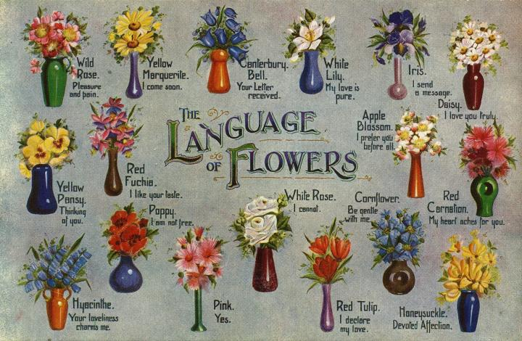

Floriography is the 'language of flowers'. Dating back to the Victorian times floriography was used as a means of coded communication through various flowers and floral arrangements, allowing people to express feelings which otherwise could not be spoken. Although the use of flowers to convey messages had been used in Persia and the Middle East, it was during the Victorian Period and the publication of flower dictionaries explaining the meaning of plants, flowers and herbs, that the tradition began to spread throughout England. Soon it became popular to use flowers to send secretive messages. Though often used to relay positive messages of interest, affection and love, flowers could also send a negative message and at times, the same flower could have opposite meanings depending on how it was arranged or delivered.

Much of Victorian etiquette was dictated by who was around to observe the behaviours and manners of others. There was a clear distinction between upper class, middle-class, and the poor. Proper etiquette often limited communications based on people of another social status, of a different gender, or within social situations. Even within the same social class, many topics were taboo and it was impolite or downright rude to ask openly about relationships. Flirtations did take place, but often secretly. Some customs have been passed along and continued to be followed today such as men removing their hats when indoors, showing respect to women by opening doors for them or bringing a hostess gift to parties or when staying with someone. The gifts most exchanged during social engagements in the Victorian Era were flowers and careful consideration was given to be certain the flowers sent the message intended.

The earliest flower dictionary was written in 1819. Written in Paris, it was called Le Language de Fleursand. In 1879, an entire book written by Miss Corruthers of Inverness, which quickly became the guide to the meanings behind flowers throughout England and the United States. This was when tussie-mussies, nosegay bouquets were first introduced.

Tussie-mussies were small handheld fragrant bouquets often wrapped in lace doilies. Most often, they were a combination of fragrant herbs; each had its own meaning and a single central flower. Great care was taken to combine the selection in such a way that its meaning was accurately expressed. Tussie-mussies were also known as nosegays. They were sometimes carried at nose level to block out some of the unpleasant odours common during the Victorian Era. Suitors presented tussie-mussies to their ladies and watched to see if they were held at heart level, which indicated happiness and acceptance. Tussie-mussies held pointing downward were a sign of rejection. Though today’s bridal bouquets are generally larger than a nosegay, they are a modern example of a tussie-mussie.

Not only did a certain flower have significance, but colours also expressed variations in intent or emotions. Even today, a red rose is said to be an expression of passionate or true love, a pink rose is a sign of warm affection, white roses are associated with purity, and yellow roses with friendship.

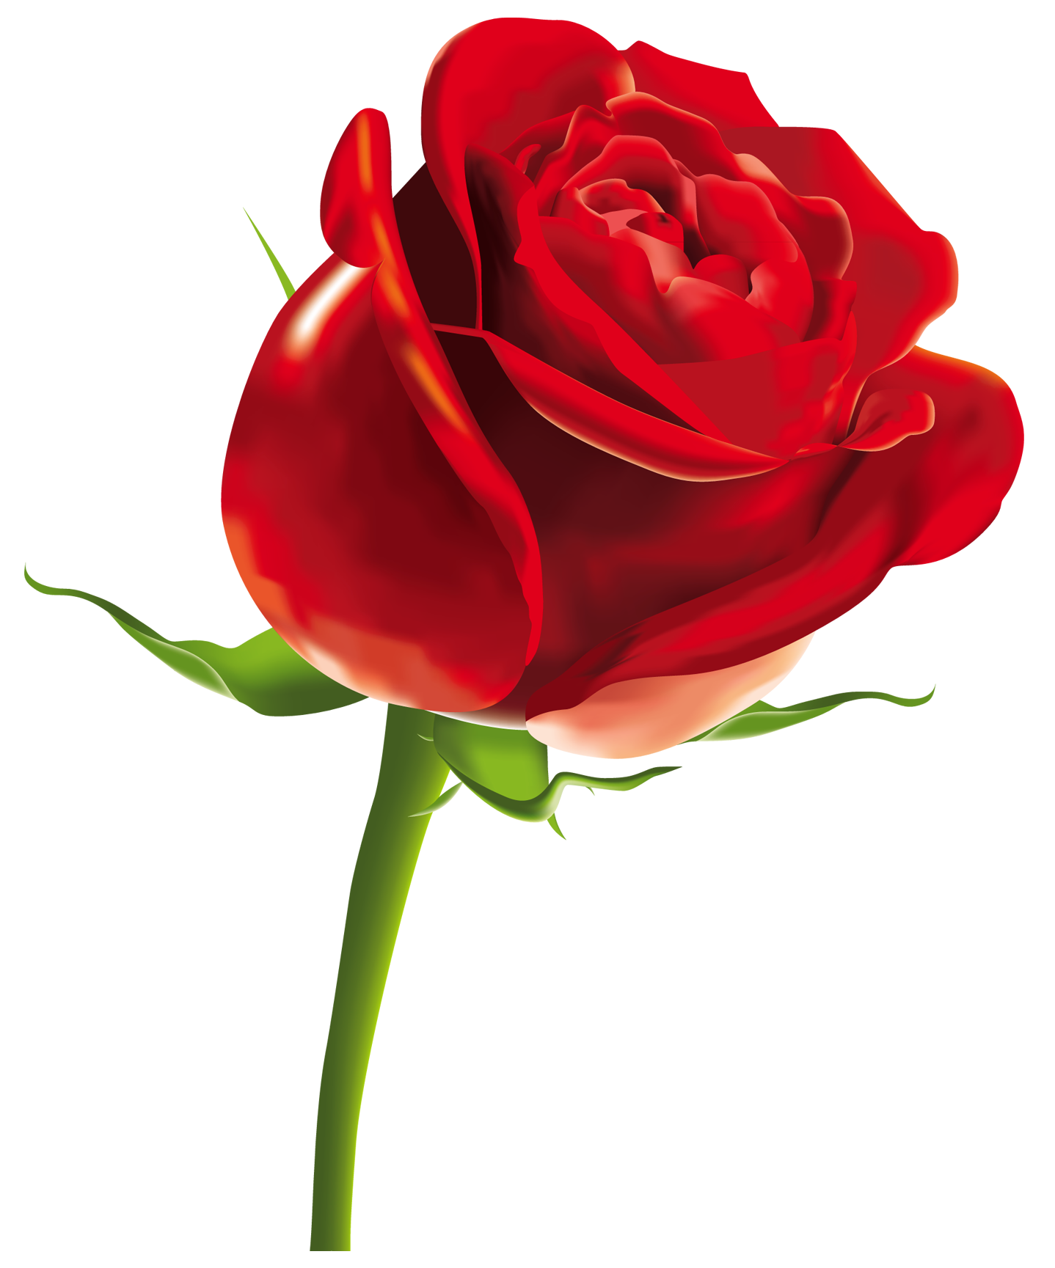

[**Daisies**](https://www.1800flowers.com/daisies)**: daisies often symbolized innocence and purity.**

[**Roses**](https://www.1800flowers.com/roses)**: as they still do today, roses symbolized love in the Victorian Era.**

**Crocuses: crocuses were said to mean youth and cheerfulness.**

**Carnation In general, carnations are said to symbolize both beauty and pride. However, a carnation’s meaning can also be broken down by the color that you’re referring to. Take a pink carnation for instance – these are said to represent gratitude or the love of a woman, whereas white carnations often symbolize remembrance or pure love.**

**Daffodil The daffodil is known to have a few meanings: on one hand, it is known to symbolize chivalry. On another, it is said to symbolize new beginnings! Speaking of new beginnings, daffodils are also generally associated with the start of spring!**

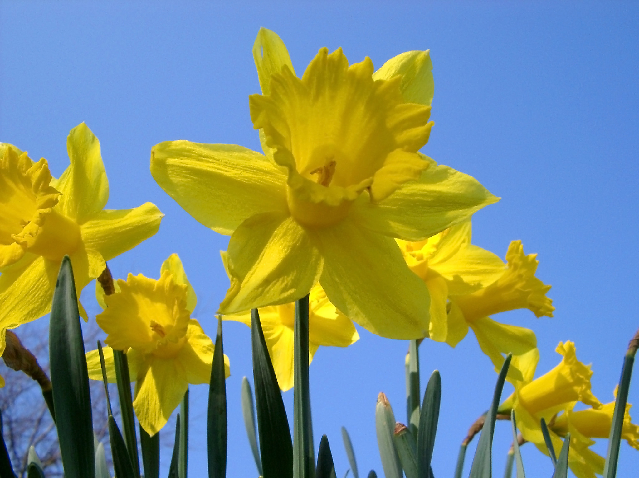

[**Gardenias**](https://www.1800flowers.com/gardeniaplants)**are the go-to flower for those who want to share their feelings of love with somebody without being known – they are said to symbolize a secret love. Additionally, they can be used in a non-romantic way as they are also symbolic of joy.**

[**Orchids**](https://www.1800flowers.com/orchids)**symbolize love, fertility, thoughtfulness and charm. Highly regarded with respect to femininity, they also strongly suggest an element of exotic beauty.**

**Tulip A popular flower found in our gardens during the summer, tulips are said to symbolize a perfect love – this love can be between family members, friends or of course, partners. On a different note,**[**tulips**](https://www.1800flowers.com/tulips)**also represent charity and royalty.**