**CHURCH SERVICES**

**Sundays**

8.15am Holy Communion (Book of Common Prayer)

10.15am Family Communion (Common Worship) - with Sunday Club and Crèche (followed by tea or coffee fellowship)

6.00pm Evensong

**Healing**

A Healing Service will be held on the 1st Sunday of each month during the 8.15am communion service and also at 10.15am.

**Baptisms**

Baptisms will take place (by prior arrangement) at 12 noon, second and forth Sunday of every month. The November service is held on the third Sunday only To arrange a Baptism see Mr. Keith Houghton MBE after the 10:15 am service (approx 11:30am) ( 01942 797838).

There will be no Baptisms in Lent.

**Arrangements for Weddings**

For weddings, parishioners should see Rev. Martin Cox at the Vicarage. Please telephone and make an appointment in advance (01942 883313) .

**Pastoral Needs and Visits**

Parishioners with pastoral needs (requests for counselling, personal problems or advising of illness) or any request of an urgent nature should contact the vicarage direct on telephone 01942 883313.

Housebound sick communions can also be undertaken and any parishioner not presently on the sick communion list, who wishes to be considered to receive such a visit, should advise clergy accordingly.

***Martin, our Team Rector, has a rest day towards the end of each week. Please make contact with him as you need to on 01942 883313 and he will respond to you as speedily as he can.***

**St. George’s Church**

We now have a website for you to use, with lots of up to date and interesting information. We welcome your feedback.

http://www.tyldesleystgeorge.co.uk

**The Parish Church of**

**St. George, Tyldesley.**

**September 2017**



Parish News

**OFFICIALS**

**Team Rector: Rev. Martin B Cox**

7 Holbeck Astley M29 7NL

***01942 883313***

**Team Vicar: Rev. Julian Hartley**

St. John’s Vicarage, Mosley Common

***0161 790 2957***

**Ordained Local Rev. Angela J Dand**

**Minister: *01942 879608***

**Ordained Pioneer Rev. Jan Harney**

**Minister: *01942 671481***

**Reader : Mr. David Kerfoot**

***01942 870736***

**Churchwarden: Mrs. Kathleen Topping**

***01942 884746***

**Treasurer Mr. Jonathan Jones**

**07971 616263**

**“Together in worship, love and service”**

**September Edition 2017**

Dear friends

When I preached at St. Stephens the other Sunday, I preached on the subject of ‘Faith’, based on the story in the Bible of Jesus teaching his disciples about that subject in Matthews gospel chapter 14 verses 22 – 33. The gospel story was the one where Jesus had gone off to a quiet place to pray whilst instructing his followers to get aboard a boat and meet him on the other side of the water.

During the trip a storm arose and the disciples, despite some of them being hardened fishermen, became frightened. Jesus appeared walking towards them on the water. Peter being unsure, shouted across the storm enquiring if it really was Jesus coming towards them. Jesus’ reply to Peter was simply ‘come’. Peter started walking on the sea towards Jesus but when he noticed how severe the storm was his faith failed and he began to sink. Peter shouted out ‘Lord, save me’. Immediately Jesus reached out to him and caught his hand, saying, ‘You of little faith, why did you doubt me’?

The most important requirement of Christian life is faith. Faith in the New Testament covers a wide area of human trust and trustworthiness. This merges from love at one end of the scale to loyalty at the other. In faith, we as Christians have trust or faith in God and in what he has done and continues to do for his world.

Here is the little story that I told to help us to further understand, written by an unknown author.

One night a house caught on fire and a young boy was forced to flee by himself to the roof. His father stood on the ground below with outstretched arms. He called to his son ‘Jump and I’ll catch you’. The father knew that the boy had to jump to save his life. All that the boy could see though was flame, smoke and blackness. As you can imagine he was afraid to leave the roof. His father kept on

**From the Registers July 2017**

|  |  |  |  |  |  |  |  |  |  |  |  |  |  |  |  |  |  |  |  |  |  |  |  |  |  |  |  |  |  |  |  |  |  |  |  |  |  |  |  |  |  |  |  |  |  |  |  |  |  |  |  |  |  |  |  |  |  |  |  |  |  |  |  |  |  |  |  |  |  |  |  |  |  |  |  |  |  |  |  |  |  |  |  |  |  |  |  |  |  |  |  |  |  |  |  |  |  |  |  |  |  |  |  |  |  |  |  |  |  |  |
| --- | --- | --- | --- | --- | --- | --- | --- | --- | --- | --- | --- | --- | --- | --- | --- | --- | --- | --- | --- | --- | --- | --- | --- | --- | --- | --- | --- | --- | --- | --- | --- | --- | --- | --- | --- | --- | --- | --- | --- | --- | --- | --- | --- | --- | --- | --- | --- | --- | --- | --- | --- | --- | --- | --- | --- | --- | --- | --- | --- | --- | --- | --- | --- | --- | --- | --- | --- | --- | --- | --- | --- | --- | --- | --- | --- | --- | --- | --- | --- | --- | --- | --- | --- | --- | --- | --- | --- | --- | --- | --- | --- | --- | --- | --- | --- | --- | --- | --- | --- | --- | --- | --- | --- | --- | --- | --- | --- | --- | --- | --- |
| **Date Service Communicants Children Adults**   |  |  |  |  |  | | --- | --- | --- | --- | --- | | 2nd | Holy Communion | 7 |  | 7 | |  | Sung Eucharist | 41 | 3 | 43 | |  | Evening Prayer |  |  | 3 | | 9th | Holy Communion | 6 |  | 6 | |  | Sung Eucharist | 37 | 2 | 38 | |  | Holy Baptism |  | 10 | 65 | |  | Evening Prayer |  |  | 3 | | 16th | Holy Communion | 7 |  | 7 | |  | Worship Together | 34 |  | 35 | |  | Evening Prayer |  |  | 3 | | 23rd | Holy Communion | 9 |  | 9 | |  | Sung Eucharist | 34 | 2 | 32 | |  | Holy Baptism |  | 25 | 165 | |  | Evening Prayer |  |  | 3 | | 27th | Funeral |  | 6 | 200 | | 28th | Team Prayers |  |  |  | | 30th | Holy Communion | 7 |  | 7 | |  | Sung Eucharist | 38 | 1 | 41 | |  | Evening Prayer |  |  | 3 | |  |  |  |  |  | |  |  |  |  |  | |  |  |  |  |  | |

**Collection Totals July 2017**

|  |
| --- |
| **Cash Cash GA Planned Giving GA Planned giving**  £371.33 £20.00 £756.00 £476.33  **Regular anonymous gift to the Restoration Fund**  £10-00 / per week  **Donations** £98.00 **Organ** £20.00 **Com. Fund** £16.00 |



**September Flower List**

We thank the following members of the congregation for Altar flowers in September"

3rd September. The Braddock Family Mrs M Wood

10th September Mr & Mrs J Hardman Mrs Margaret Stubbley

17th September. Mrs Joan Berry

24th September. Mr & Mrs J Fearick

Our thanks to Mrs Margaret Hook and children for additional altar flowers in Loving Memory of her dear daughter Jennifer Ann on 20 August.

On 27th August we thank Mrs Lilian Grime for altar flowers in Loving Memory of her dear Husband Norman and her dear son Philip.

Also on that date we would like to thank the family of the late Lilian and Clifford Hodcroft for altar flowers in remembrance of their wedding anniversary.

Thank you to everyone who has supported the Flower fund during August.

L.F

yelling ‘jump and I’ll catch you’. But the boy protested ‘Daddy, I can’t see you’.

The father replied, ‘but I can see you and that’s all that matters’.

When we are apprehensive about faith and the fears and troubles that surround us and we doubt Christ’s presence and ability to help, we must have faith and always remember that he is the only one who can truly help and guide us.

Keith Revill

**Consolation**

To the family of

Stanley Jones

*May he rest in peace and rise in glory*

**Welcome to the Family**

Connor Jack Sargeant

Jordan Ralph Newton

Ralph John Newton

*Newly Baptised*

**MAKING ST.GEORGE’S A PLACE OF WELCOME.**

At the last meeting of our PCC, we considered your responses to my presentation in February. And we have now agreed on our first new initiative, based on your proposals, and it is to make St.George’s a ‘Place of Welcome’.

This will involve opening our church building for a few hours on the same day each week every week to offer an unconditional welcome to any local people who might wish to drop in. The resources we will need are some volunteers willing to chat with people, to provide them with a free cup of tea or coffee and a biscuit, and some leaflets on where people can get advice and help on some basic community problems. And where we go from there is up to us. People could light a candle for someone, for example, if they wished to, or we might be able, with the support of ‘Fur Clempt’ to have a modest food boutique. In short, it is something that we can set up with limited resources and develop over time. Provided, of course we have sufficient volunteers to get it up and running.

It has been said to me on numerous occasions over the years it would be good if our church building were open not simply for services but at other times too. And making St.George’s a place of welcome, gives us that opportunity. If you would like to help with this in some way, or simply would wish to find out more, please have a word with me as soon as possible, as we would hope to make a start in early September. Please do support this important new initiative if you can; your help, as always, would be much appreciated.

David

**Kerry Garner**

**Worship and Music Administrator**

Victoria Street

Manchester

M3 1SX

0161 833 2220 (ext. 238)

Fax: 0161 839 6218

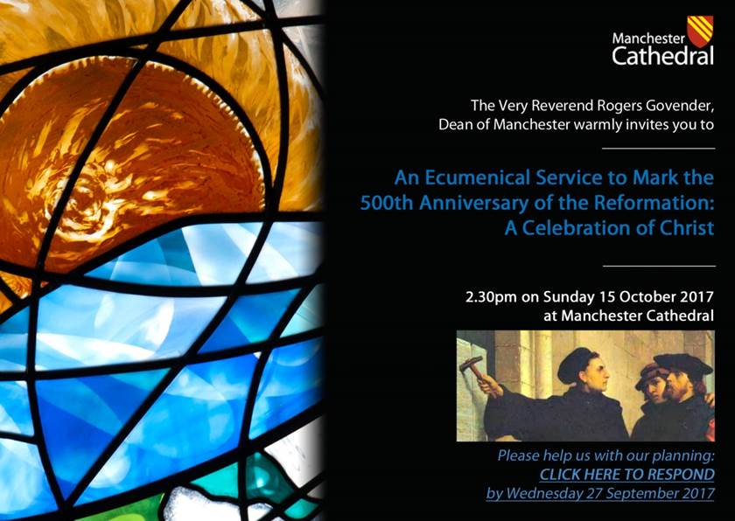

<http://www.manchestercathedral.org/reformation-500-service-2>