**CHURCH SERVICES**

**Sundays**

8.00am Holy Communion (Book of Common Prayer) 1st & 3rd Sunday

Morning Prayer ( Book of Common Prayer ) 2nd & 4th Sunday

10.30am Morning Worship (Service of the Word) 1st Sunday

Sung Eucharist ( Common Worship ) 2nd,3rd & 4th Sunday

with Sunday Club and Crèche (followed by tea or coffee fellowship)

Services on the 5th Sunday as announced

**Healing**

A Healing Service will be held on the 3rd Sunday of each month during the 8.00am communion service and also at 10.30am. Unless otherwise announced.

**Baptisms**

Baptisms will take place (by prior arrangement) at 12.15 pm, 2nd & 4th Sunday of every month, except during Lent. The November service is held on the third Sunday only To arrange a Baptism see Mr. Keith Houghton MBE after the 10:30 am service (approx 11:45am) ( 01942 797838).

**Arrangements for Weddings**

For weddings, parishioners should see Rev. Martin Cox at the Vicarage. Please telephone and make an appointment in advance (01942 883313) .

**Pastoral Needs and Visits**

Parishioners with pastoral needs (requests for counselling, personal problems or advising of illness) or any request of an urgent nature should contact the vicarage direct on telephone 01942 883313.

Housebound sick communions can also be undertaken and any parishioner not presently on the sick communion list, who wishes to be considered to receive such a visit, should advise clergy accordingly.

***Martin, our Team Rector, has a rest day towards the end of each week. Please make contact with him as you need to on 01942 883313 and he will respond to you as speedily as he can.***

**St. George’s Church**

We now have a website for you to use, with lots of up to date and interesting information. We welcome your feedback.

http://www.tyldesleystgeorge.co.uk

**The Parish Church of**

**St. George, Tyldesley.**

**November 2018**



Parish News

**OFFICIALS**

**Team Rector: Rev. Martin B Cox**

7 Holbeck Astley M29 7NL

***01942 883313***

**Team Vicar: Rev. Julian Hartley**

St. John’s Vicarage, Mosley Common

***0161 790 2957***

**Ordained Local Rev. Angela J Dand**

**Minister: *01942 879608***

**Reader : Mr. David Kerfoot**

***01942 870736***

**Churchwarden: Mrs. Kathleen Topping**

***01942 884746***

**Mr. Iain Hodcroft**

**07976 314012**

**Treasurer**

**“Together in worship, love and service”**

**November Edition 2018**

[](https://en.wikipedia.org/wiki/File:Stephenson%27s_Rocket_drawing.jpg)

On the 16th of October, 9 members of St. Stephens Men`s Group went to Manchester to see Stephenson’s original Rocket Steam Engine at the Manchester Museum of Science and industry and then attended a lecture by the Manchester Geographical Society on the opening of the Liverpool to Manchester Railway which happened in 1830.

The railway line, which still passes over Astley Moss, was the first passenger railway in the world and it was Stephenson’s Rocket that was successful in running the first trains.

We had very interesting talks both about the engine and the railway but the thing that has stuck in my mind is what the guide at the MMSI told us, when he said that the main principle of steam engines has not changed since Stephenson’s original design. There have been many developments and improvements but the principle is the same.

My thoughts were - could we not say the same about our belief and faith in God? At some time in our life, whether it be some time ago or recently, we grasped the core of faith but over time that faith, that same faith, has developed and matured into something deeper. It’s the same faith we first grasped but our understanding has hopefully developed.

Faith is about deep trust and confidence in what we believe. Stephenson had deep trust and faith that his railway engine would work, and so it did, and the same principle of steam engine design still works today.

**From the Registers September 2018**

|  |  |  |  |  |  |  |  |  |  |  |  |  |  |  |  |  |  |  |  |  |  |  |  |  |  |  |  |  |  |  |  |  |  |  |  |  |  |  |  |  |  |  |  |  |  |  |  |  |  |  |  |  |  |  |  |  |  |  |  |  |  |  |  |  |  |  |  |  |  |  |  |  |  |  |  |  |  |  |  |  |  |  |  |  |  |  |  |  |  |  |  |  |  |  |  |  |  |  |  |  |  |  |  |  |  |  |  |  |  |  |
| --- | --- | --- | --- | --- | --- | --- | --- | --- | --- | --- | --- | --- | --- | --- | --- | --- | --- | --- | --- | --- | --- | --- | --- | --- | --- | --- | --- | --- | --- | --- | --- | --- | --- | --- | --- | --- | --- | --- | --- | --- | --- | --- | --- | --- | --- | --- | --- | --- | --- | --- | --- | --- | --- | --- | --- | --- | --- | --- | --- | --- | --- | --- | --- | --- | --- | --- | --- | --- | --- | --- | --- | --- | --- | --- | --- | --- | --- | --- | --- | --- | --- | --- | --- | --- | --- | --- | --- | --- | --- | --- | --- | --- | --- | --- | --- | --- | --- | --- | --- | --- | --- | --- | --- | --- | --- | --- | --- | --- | --- | --- |
| **Date Service Communicants Children Adults**   |  |  |  |  |  | | --- | --- | --- | --- | --- | | 2nd | Holy Communion | 6 |  | 6 | |  | Morning Praise |  | 2 | 36 | | 9th | Morning Prayer |  |  | 6 | |  | Sung Eucharist | 49 | 10 | 49 | |  | Holy Baptism |  |  |  | | 14th | Team Prayers |  |  | 9 | |  | Funeral |  |  | 55 | | 16th | Holy Communion | 7 |  | 7 | |  | Sung Eucharist | 43 | 6 | 43 | | 23rd | Morning Prayer |  |  | 4 | |  | Sung Eucharist | 59 | 16 | 64 | |  | Holy Baptism |  | 15 | 75 | | 24th | Funeral |  |  | 35 | | 28th | Team Prayers |  |  | 5 | |  | Funeral |  | 1 | 33 | | 30th | Choral Evensong |  |  | 25 | |  |  |  |  |  | |  |  |  |  |  | |  |  |  |  |  | |  |  |  |  |  | |  |  |  |  |  | |  |  |  |  |  | |

**Collection Totals September 2018**

|  |
| --- |
| **Cash Cash GA Planned Giving GA Planned giving**  £168.00 £00.00 £611.00 £345.26  **Regular anonymous gift to the Restoration Fund**  £10-00 / per week  **Donations** £15.00 **Organ** £20.00 **Com. Fund** £20.00 |



**November Flower List**

“We thank the following members of our congregation

For Altar flowers in November”

4th November.                              “Open for offers”

11th November.                            Remembrance Sunday

18th November.                          “Open for offers”

25th November.                            Mrs Doris Whitworth

Our thanks to Mrs Joan Berry, Lynda and family for Altar flowers in

Loving Memory of her dear husband Harry.

Many thanks to Mrs Agnes Smith for additional Altar flowers in Loving

Memory of her dear husband Paul on 7th October.

Thank you to everyone who has supported the Flower Fund during October.

L.F..

Sometimes, like a railway engine, we may go off the rails when some hazard or difficulty, illness or anxiety besets us, but God is always there to lift us up, place us back on the rails and set us back on the right track.

At this time, when the church of God is having a difficult time in relating the truth about God to the world, let us pray that God will guide his church out of the sidings and help us put his people back on the main line to his kingdom.

Keith Revill

**Consolation**

To the family of

John Bent

Gerard Broadhurst

Robert Jones

Joyce Partington

*May they rest in peace and rise in glory*

**Welcome to the Family**

Kit Harrison Grimshaw

Alex Rose Partington

James Alexander Schofield

James Robert Holland

Jai Neil

*Newly Baptised*

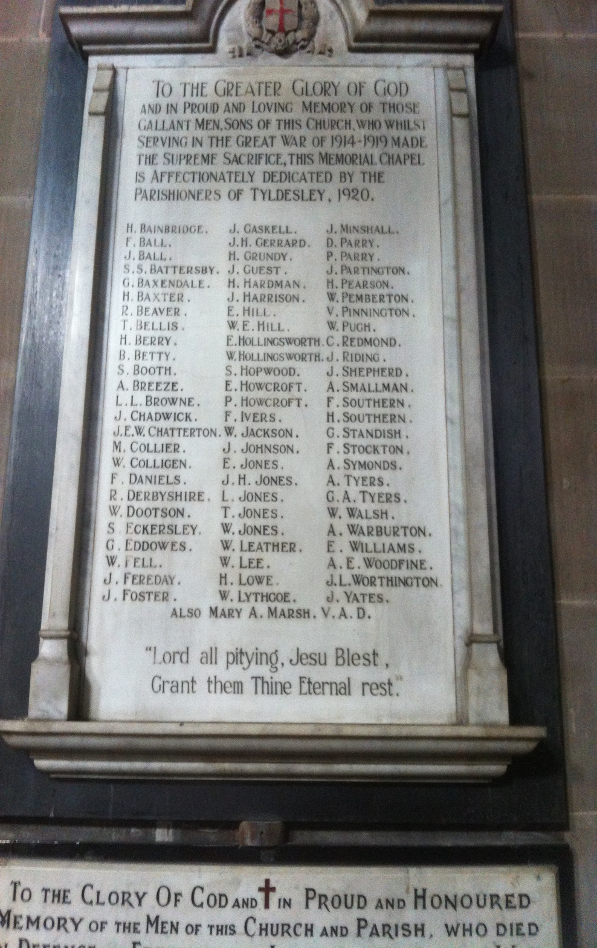

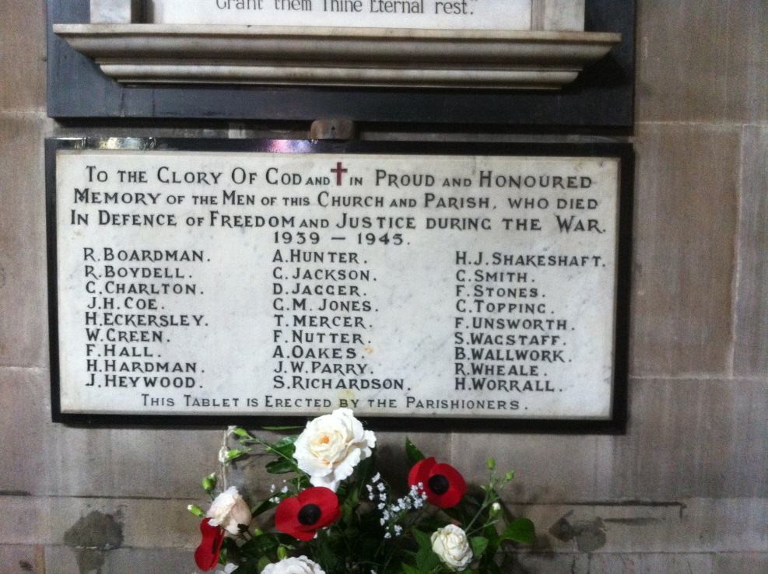

*******Advance Notice*******

Further information will follow in due course but dates for the next Team Weekend at Scargill House are confirmed as Friday 10th till Sunday 12th May 2019.

If you want to know more about Scargill House you can explore their website:

[www.scargillmovement.org](http://www.scargillmovement.org/)

or speak to Susie Mallon / Iain Hodcroft who will do their best to answer your query.