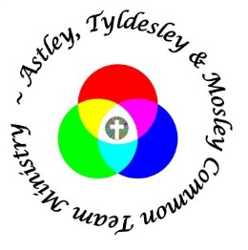
January 2019
A letter from the Team Rector
‘Bones are a different matter’
Prior to Christmas 2018 I was given a copy of Sir Alex Ferguson’s autobiography to read over the festive period by Adrian, my beloved father-in-law. In his autobiography, Sir Alex writes about the players he managed during his long period as the Manchester United football manger, including Roy Keane and David Beckham. He writes of the injury that David Beckham suffered before a World Cup tournament:
‘The obsession with David’s recovery was predictable. An oxygen tent found its way to Carrington. We had good results from that device on Roy Keane’s hamstring injury before a European game. Bones are a different matter. The cure is rest. It’s time. A metatarsal is a six-to-seven week injury’ (p71)
Well I am no David Beckham or Roy Keane, but I can now bear testimony to the reflection that it is time that heals broken bones.
On Thursday 27th December, Heather and I were out for an afternoon walk in Astley with some members of our family. It was 2.15pm. I slipped on wooden decking and crashed to the floor. I heard the crack as I went down and could see my right foot moving freely. I knew instantly that I had suffered some sort of fracture or break.
I was given immediate attention by family members and passing members of the local community. I was covered in blankets and Mike knelt for over an hour with his knee under my right knee to take the pressure off the damaged leg. Thank you. Although a defibrillator was sourced at the request of the emergency service it was thankfully not needed as the ambulance arrived at 3.45pm before I went into shock. Gas and air were administered. I was transferred to the ambulance and taken to the Royal Bolton Hospital.
X-rays revealed that I had suffered a complete fracture to the lower part of my right tibia and a partial fracture of the upper right fibula. I was duly admitted on to Ward G3 and surgery followed the day after. The surgical procedure involved the insertion of an intramedullary nail and screws top and bottom to the right tibia, which is inserted via the knee cap and with a bit of drilling to the top of the tibia.

An Example
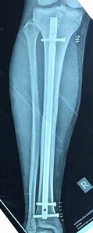
It is an amazing procedure. As I result a plaster cast was not necessary; heavy bandaging was required for two weeks following the operation to protect the wounds and the fibula prior to the removal of stitches.
On a scale of 1 to 10, the pain I experienced was 11. It was excruciating. The pain is still significant but is under control most of the time. As I write this piece I am at home with my right leg elevated and with crutches on hand as I am able to walk around the house as the doctors are OK with me using my right leg for weight bearing. There continues to be pain and swelling in the right leg, but x-rays have shown that the bones are knitting together well.
I would like to express my thanks for the get well messages and cards that I have received from folk across the team and for your prayers. I would like to express my gratitude to the staff who work at Royal Bolton Hospital for their holistic care; I never once felt like the broken leg in bed two. I would like to express my thanks to the team for covering the inevitable gaps in the rota caused by my unforeseen sickness absence. I would to thank my lovely and patient wife, Heather for her TLC which has brought much comfort during this period. I am on the mend, but it will take time to be fully fit. As Sir Alex Ferguson reflects in his autobiography, ‘bones are a different matter.’
As a Christian I firmly believe that our brokenness is transformed by the Cross of Christ. It is not flippant at all for me to close by reflecting that the nail I now have in my right leg is a permanent physical reminder to me of this theology, which I hold so dear.
And finally…..my belated New Year’s resolution is to never, ever again use the expression ‘Go, break as leg’ as a means of encouraging others! Broken legs are very painful and are to be avoided wherever possible.
Yours in His service
Martin Revd Martin Cox

