Parish Church of St George, Tyldesley

Parish News October 2019

Team Rector: Rev. Martin B Cox 01942 883313
7 Holbeck Astley M29 7NL

Team Vicar: Vacant 0161 790 2957
St. John’s Vicarage, Mosley Common

Ordained Local Rev. Angela J Dand 01942 879608
Minister:

Reader: Vacant

Churchwarden: Mr. Iain Hodcroft 07976 314012

Team Clerk Miss Susan Mallon 07873 149627

Astley, Tyldesley and Mosley Common Team Ministry
“Together in worship, love and service”
October 2019 Reflection

Dear friends
James in his letter in chapter 1 verse 17 says that “every good gift and every perfect gift is from above”

October is a lovely month of colour and celebrations when the world around us looks very beautiful as flowers, fruits and vegetables reach their maturity and leaves turn into delightful colours of reds, oranges and yellows. It is as though all nature is shouting out for us to look at it.

Whenever I think of autumn and harvest, my thoughts often turn to an early 20th century hymn written by an American Methodist Minister from Kentucky. When Thomas Chisholm wrote it in 1923, I don’t think he was intending it to be a hymn especially for harvest but the second verse always reminds me of harvest.

“Summer and Winter and Spring time and harvest
sun, moon and stars in their courses above
join with all nature in manifold witness
to thy great faithfulness, mercy and love.”

Thomas Chisholm was reading and reflecting at the time on a passage from Lamentations chapter 3, verses 22 + 23 and the hymn is based on his thoughts from there. “The steadfast love of the Lord never ceases, his mercies never come to an end, they are new every morning, great is your faithfulness.”

As he reflected, he thought how one of the important lessons the children of Israel had to learn during their wilderness journey was that God’s provision of manna for them was on a morning by morning basis (Exodus chapter 16 v 19 – 21). They could not store for future use and by the time the sun was up it would melt away. They had to trust in the faithfulness of God and his provision for them. Thomas Chisholm penned the words, “All I have needed thy hand hath provided, great is thy faithfulness Lord unto me”

Looking back on Israel’s history it is not surprising that Israel’s main religious festivals were closely linked with the seasons and the farmer’s year. Their first harvest was the grain harvest, which followed 50 days (7 weeks) after Passover. When the people brought their offerings to God they were reminded that the land and everything it provided was God’s gift to them and so it was a time of great thanksgiving.

At the end of the fruit harvest when the grapes and olives had been gathered in they celebrated with the Feast of Tabernacles or Shelters which reminded them of the time their ancestors had no permanent homes to live in during their 40 years wanderings in the wilderness.

We too can praise and thank God this harvest time for his constant love and provision throughout the year.

“Pardon for sin and a peace that endureth,
thine own dear presence to cheer and to guide;
strength for today and bright hope for tomorrow
blessings all mine with ten thousand beside!”
Great is God’s faithfulness to each one of us.

With good wishes,
Jean Wlliamson
+++++++++++++++++
From the Registers August 2019

Date | Service | Commun - icants | Children | Adults
4th | Holy Communion | 7
 | Morning Praise |  | 8 | 37
11th | Morning Prayer |  |  | 6
 | Sung Eucharist | 32 | 3 | 2
 | Holy Baptism |  | 15 | 120
18th | Holy Communion | 7
 | Sung Eucharist | 37 | 2 | 1
25th | Morning Prayer |  |  | 6
 | Sung Eucharist | 28 | 5
 | Holy Baptism |  | 20 | 137

INCOME (July) (August)
Cash (now all eligible for Gift Aid) £289.71 £267.87
Planned Giving £335.20 £442.45
Planned Giving (Gift Aid) £400.00 £500.00
Restoration £94.60 £150.00
Organ £10.00
Community Fund £20.00 £20.00
Sundry Donations £140.00

Welcome to the Family …

Jackson James Crowther
Kris Allingham
Scott Allingham
Isla Grace Allingham
Tommy Arthur Dixon
Shay Edward Smith

‘Newly Baptised.’

++++++++++++++++

Service information for October 2019
Date | 8am | 10.30am
6th | Holy Communion | Morning Prayer
13th | Morning Prayer | Sung Eucharist
20th | Holy Communion with Healing | Sung Eucharist with Healing
27th | Morning Prayer | Sung Eucharist for Harvest
Please remember our new Sunday Afternoon service for baptism families – “Families@Four” – Sundays 6 October and 3 November at 4.00pm. relaxed hospitality and food included!
++++++++++++++
Friday prayers: members of all three churches ad guests meet for prayer at 9.30am, every Friday morning in the Lady Chapel. Every one is made welcome – and there is a mix of bible readings, a reflection and open prayer, with space for silent prayer. Come along and join us, and then move straight into the Place of Welcome for ongoing fellowship.

October Flower List
'We thank the following members of our congregation
for Altar flowers in October”
Sunday 6 October anonymous
Sunday 13 October ‘open for offers’
Sunday 20 October ‘open for offers’
Sunday 27 October Mrs Jean Pearson

On 14 September we thank Mrs Margaret Stubbley for additional flowers in Loving Memory of her dear husband Lew and his brothers and sisters.

Also on that date we thank Mrs Jean Wilcock and Family for additional flowers with Loving Birthday Memories of her dear husband Tom.

Mrs Joan Berry, Lynda and Family provided Altar flowers in Loving Memory of her dear husband Harry.

Our thanks to everyone who brought fruit and vegetables to church to celebrate our Harvest Festival.......this has now been distributed to those in need in our neighbourhoods.

Thank you to everyone who has supported the Flower Fund during September. L.F
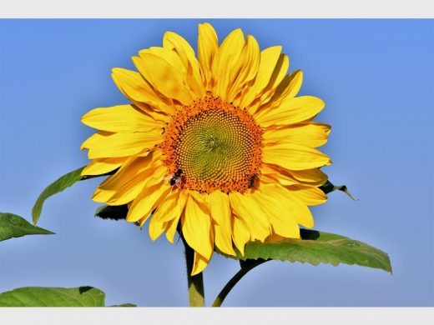

CHURCH CHANGES:

- Arrangements for booking baptisms
Martin is introducing an ‘office hour’ to meet with families making enquiries or wishing to book baptism at St George’s.
The next two are as follows:
Monday 30 September 6.00pm – 7.00pm
Monday 4 November 6.00pm – 7.00pm.

+++++++
- Eucharistic Assistants
Several people stepped up to become our new Eucharistic Assistants. If anyone else missed the preparatory meeting and wish to become involved, please see Martin.

+++++++

- Intercessions
If anyone would like to volunteer to lead weekly intercessions, please see Martin or Iain. Help will be offered! We only have four regular contributors, so please join us!

+++++++

Church Events:
The Big Lunch –
Thank you to everyone who supported this event. It is hoped that it will become an annual event – bigger and better, next year!

Fruits of the Harvest Gin Festival
Following a fantastic evening on Friday 27 September, with over 110 people enjoying the atmosphere in church, the different conversations taking place from 6.00pm to well after 10.00pm, the relaxed nature of the event – oh, and a few tastings of well over a 100 gins on offer! It was a success on many levels. A big thank-you to everyone who supported those who planned, preparedparticipated stayed behind to clear up, and returned the following day to make sure church was ready for services again.

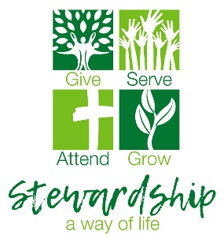
A major Stewardship Campaign is to be discussed at PCC – our regular income has reduced considerably.
Apologies to parishioners and visitors as church is still disrupted (28 September) whilst our new heating system is being installed. There is a degree of disappointment that work will spill over into October, as we struggle to get an electrician to connect everything, so we can flick that switch for the first time! The lads from HeatinGlobal have been easy to work alongside, have respected funerals and other times where quiet has been needed and have helped keep the building as clean as possible.

Kindness Box

Thank you to everyone who has helped with donations for the Red Box Project

This is changing, so please read the update – our help is still required!

Donations can be placed in the ‘red box’ at the back of church next to the food bank box.

Thank you.

St George’s Church
“Rooted in God’s love,
Growing together with Jesus,
Ministering in the power of the
Holy Spirit.

