Parish Church of St George, Tyldesley

3rd Sunday of Easter

Sunday, 26 April 2020

Prayers of Intercession 

Astley, Tyldesley and Mosley Common Team Ministry

“Together in worship, love and service”

Risen Lord, we pray in the glorious light of Christ, who leads his people in all their worship and adoration. Lord, as we continue our Easter journey make us mindful of our potential for good and for growth, despite the restrictions we are having to adjust to. Help us all to be responsible in the things that we do in our lives, in our new daily realities, and to adapt the unchanging Gospel message to today’s needs.

Risen Lord,

**Fill our hearts with Easter joy**

Risen Lord, you set ablaze the hearts of your disciples with awe and wonder at your resurrection.

Although we are unable to gather in fellowship and worship together, open the eyes of your Church as you did with Jesus’ companions, to the reality and truth of this astounding news – that Jesus lives.

Fill our voices with joy that you are indeed risen

Risen Lord,

**Fill our hearts with Easter joy**

Risen Lord, you see and judge the motives of rulers and leaders.

Raise up and sustain with your Holy Spirit people of integrity for the responsibilities of government; help them to develop strategies to contain and deal with the virus. We pray specially for those in the health and caring services who are risking their own lives to stay alongside and care for sick patients.

Bring peace and justice to flourish

Risen Lord,

**Fill our hearts with Easter joy**

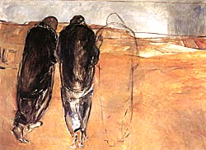 Risen Lord, you drew alongside confused disciples as they journeyed to Emmaus.

Give grace to all who accompany others in their searching, be this as prosaic as modelling Christian mission by shopping for the vulnerable or as exceptional and inspired as supporting others struggling with their mental health and sense of wellbeing.

Risen Lord,

**Fill our hearts with Easter joy**

Risen Lord, you incline your ear to all who call upon you,

Free us from the bonds that restrict our movement and dampen our praises Heal all who are sick, stay by our side in this time of uncertainty and sorrow.

Heal us from our fear – help nations and neighbours work together and help one another.

Heal us from our pride, and any sense of invulnerability in our neighbourhoods.

Bless all who set their hope and trust on you.

Risen Lord,

**Fill our hearts with Easter joy**



Risen Lord, you came to your disciples in the darkness and impaired vision of their grief.

Come close to all whose hearts are anguished by loss, accompany those travelling through the valley of death. May Your love and compassion support those who walk that journey today.

Bring us to rejoice in your eternal Kingdom.

Risen Lord,

Fill our hearts with Easter joy

Risen Lord, as we go from our personal worship today, out into your changed world; we thank you for walking alongside us wherever we travel ****and, if like those first disciples, we fail to be aware of you forgive us for our human weakness and open our eyes to see you as a  constant companion and friend.

May we show and share our love and trust for you wholeheartedly, today, and every day as we know not what tomorrow brings.

Merciful father:

**accept these prayers for the sake of your Son, our Saviour, Jesus Christ.  Amen**

**Acts 2.14a,36-41**

(Peter said), “Therefore let the entire house of Israel know with certainty that God has made him both Lord and Messiah,[[a](https://www.biblegateway.com/passage/?search=Acts+2%3A+14a%2C+36-41&version=NRSVA#fen-NRSVA-26975a)] this Jesus whom you crucified.”

**37**Now when they heard this, they were cut to the heart and said to Peter and to the other apostles, ‘Brothers, what should we do?’ **38**Peter said to them, ‘Repent, and be baptized every one of you in the name of Jesus Christ so that your sins may be forgiven; and you will receive the gift of the Holy Spirit. **39**For the promise is for you, for your children, and for all who are far away, everyone whom the Lord our God calls to him.’ **40**And he testified with many other arguments and exhorted them, saying, ‘Save yourselves from this corrupt generation.’ **41**So those who welcomed his message were baptized, and that day about three thousand persons were added.

**1 Peter 1. 17-23**

Since you call on a Father who judges each man’s work impartially, live your lives as strangers here in reverent fear. For you know that it was not with perishable things such as silver or gold that you were redeemed from the empty way of life handed down to you from your forefathers, but with the precious blood of Christ, a lamb without blemish or defect. He was chosen before the creation of the world, but was revealed in these last times for your sake. Through him you believe in God, who raised him from the dead and glorified him, and so your faith and hope are in God. Now that you have purified yourselves by obeying the truth so that you have sincere love for your brothers, love one another deeply, from the heart. For you have been born again, not of perishable seed, but of imperishable, through the living and enduring word of God.

**St. Luke 24. 13-35**

That same day two of the disciples were going to a village called Emmaus, about seven miles from Jerusalem. They were talking with each other about everything that had happened. As they talked and discussed these things with each other, Jesus himself came up and walked along with them; but they were kept from recognising him. He asked them, "What are you discussing together as you walk along?" They stood still, their faces downcast.

One of them, named Cleopas, asked him, "Are you only a visitor to Jerusalem and do not know the things that have happened there in these days?" "What things?" he asked. "About Jesus of Nazareth," they replied. "He was a prophet, powerful in word and deed before God and all the people. The chief priests and our rulers handed him over to be sentenced to death, and they crucified him; but we had hoped that he was the one who was going to redeem Israel. And what is more, it is the third day since all this took place. In addition, some of our women amazed us. They went to the tomb early this morning but didn't find his body. They came and told us that they had seen a vision of angels, who said he was alive. Then some of our companions went to the tomb and found it just as the women had said, but him they did not see." He said to them, "How foolish you are, and how slow of heart to believe all that the prophets have spoken! Did not the Christ have to suffer these things and then enter his glory?" And beginning with Moses and all the Prophets, he explained to them what was said in all the Scriptures concerning himself.

As they approached the village to which they were going, Jesus acted as if he were going further. But they urged him strongly, "Stay with us, for it is nearly evening; the day is almost over." So he went in to stay with them. When he was at the table with them, he took bread, gave thanks, broke it and began to give it to them. Then their eyes were opened and they recognised him, and he disappeared from their sight. They asked each other, "Were not our hearts burning within us while he talked with us on the road and opened the Scriptures to us?"

They got up and returned at once to Jerusalem. There they found the Eleven and those with them, assembled together and saying, "It is true! The Lord has risen and has appeared to Simon." Then the two told what had happened on the way, and how Jesus was recognised by them when he broke the bread.

***“Rooted in God’s love,***

***Growing together with Jesus,***

***Ministering in the power of the***

***Holy Spirit.”***

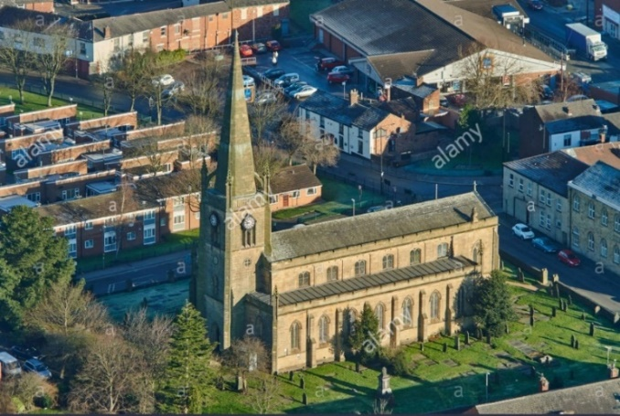

**+++++++++++++**

Anyone who has walked past church recently, should have seen the tremendous improvements being made as Frank and Carl plant bushes and shrubs in the churchyard garden.

**Thank You**

If any parishioners can donate cuttings or plants please contact me !! text 07976 314012 and I’ll arrange for them to be collected.