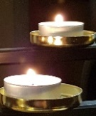
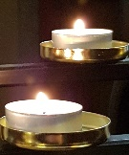
In Memoriam

We remember in our prayers the families of those who have died during the four months of the pandemic lockdown,
including those families specifically supported by members of the local ministry team:

John Hampson
Deryck Leyal
Catherine Watson
Anthony Michael Smith
Enid Keefe
Elizabeth Horrocks
Kenneth (Ken) Victor Lewis
(Richard) Gerald Meekin
Barbara Newall
Philip Dornan
Frances Smallman
Brenda Bailey
Lois Wood
(Ann) Pat Starkey
Jean Clemson
Brian Glover
Darren Lee Hodgkinson
Egon (Fred) Auerswald
Margaret Goddard
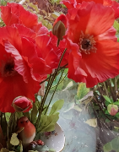

We are also asked to remember in our prayers the families of:
Paul Kinsella
Frank Aspinall
Bessie Farnworth
Charlie Bridges
David France
Brenda Jones
Susan Triska
Betty Jones
Jeff Cooke
Iris Waterworth
Rev Steve Wilkinson
who have also died in recent months
‘May they all rest in peace and rise in glory’

