Mary of Magdala
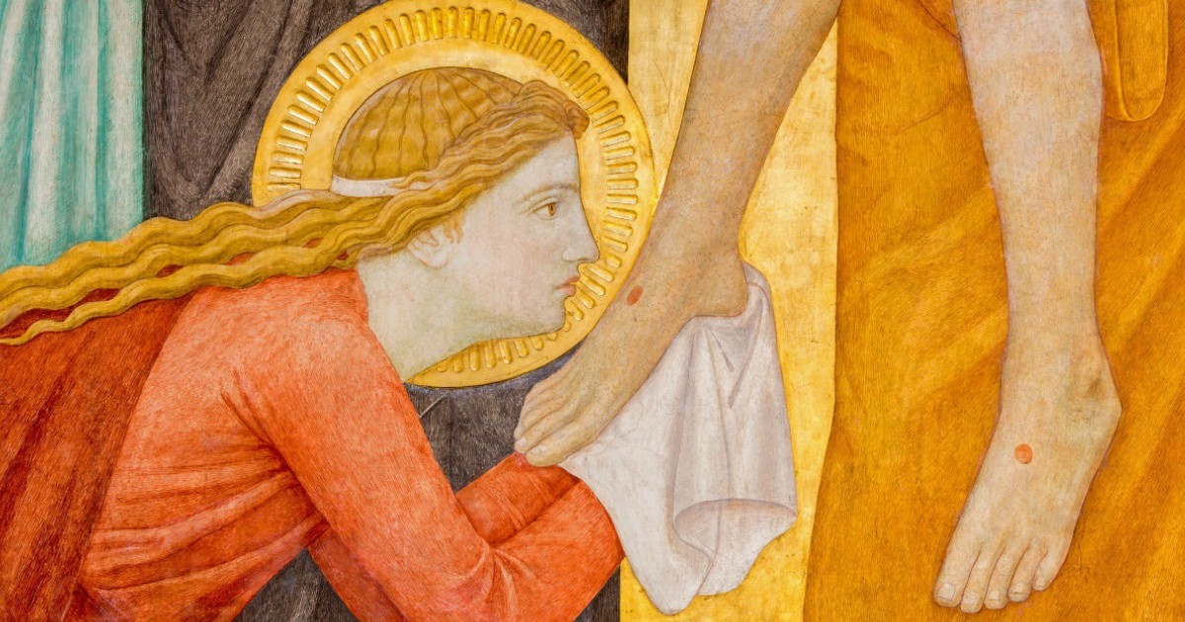

On 22nd July we celebrate Saint Mary Magdalene’s Day. Mary was from Magdala which is on the west coast of the Sea of Galilee. She was the first witness of Jesus’ Resurrection.

After Peter and John had left the empty tomb, Mary lingered behind and was met by the Risen Jesus, and so was the first to actually see him. He told her to go and tell the others. She was one of a group of women who supported Jesus and his disciples in announcing the Kingdom of God. We are told they were all women cured of evil spirits and diseases through Jesus’ ministry (Luke ch8 v1-3) What was an evil spirit or demon? Mary had seven! (the full set?) – sounds pretty bad. Demons were used to describe physical illness and also especially mental illness and perhaps sometimes a lack of morals. So her exact trouble is not known.

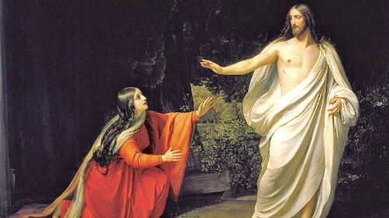

Her life was wonderfully changed by Jesus. She joined the group of disciples with other women where she would have witnessed the miracles, heard his sermons and received his teaching. She seems to have led this women’s group and they stayed with Jesus, witnessing the Crucifixion and his body being taken down from the Cross and saw where it was laid. They prepared spices and took them to the tomb where they saw the stone rolled away and the angel telling them to tell the disciples. When Peter and John arrive they discover the tomb empty and Mary crying outside. When they leave she sees an angel and asks where the body is. Jesus appears to her but she assumes he is the gardener who has somehow taken the body.

“Mary” he says. She gasps “Lord”. He sends her out to tell the others. There is no record of her after this. Yet women played an important role in those early days of the church eg: Philip’s daughters preached, Priscilla taught the leaders, Phoebe was a deacon in Rome, Junia and others are mentioned as influential.

So Mary slips into the background. Her job is done. She was a supporter. She was a witness to all that mattered and she offered her support.
Michael of St Stephens

As I was putting this into the magazine I was also watching an episode of Time Team - really in lockdown I've found I can only deal with factual programmes - which was on the Leper Hospital at Winchester which was dedicated to St Mary Magdalene. Apparently St Mary Magdalene was the Patron Saint of Lepers, as her brother was the leper Lazarus and many leper hospitals were dedicated to her! I do like learning new stuff!
Andrea of St. John's

