MOTHERS` UNION MEETING FEBRUARY 2020 Astley St Stephens

At the February meeting Jennifer led our church service, telling us about St. Valentine and choosing the hymn ‘Lead Us Heavenly Father’ sung at her wedding.

Our speaker was Nick Hardman from St Johns, Mosley Common. Nick, an RHS and Worsley Civic Trust member, is a keen gardener who works as a volunteer at the new RHS Bridgewater project at Worsley. He began by talking briefly about Worsley Old Hall and the Egerton family, before going on to talk about Worsley New Hall which overlooked the Cheshire plain and cost £100,000 to build. This magnificently large building was one of the finest homes in the country. The gardens were terraced and well planned with fountains and a large lake with vast grounds. In 1851 Queen Victoria visited the hall travelling by barge on the Bridgewater canal. During the First World War it became a military hospital but sadly was then left derelict until destroyed by fire in the 1940s and demolished.

The RHS now own the site and with the help of many volunteers, including black pigs, the land was cleared. New buildings have been built and many new gardens and trees planted. Walls have been cleaned and car parks made. The lake has been drained and unsilted then left to fill naturally. There is still a lot of planning and work ahead. Phase 1 was meant to open in July 2020, but is now put back to May 2021.

During this most interesting talk Nick projected before and after photos onto the wall, aerial shots and old photos of the hall. The talk was well supported by MU members, the Men’s group and St Stephen’s congregation.
Pauline Roberts of St Stephens
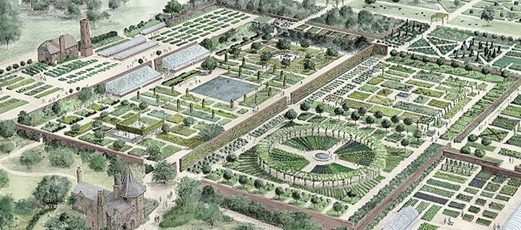

FROM THE REGISTERS OF ST STEPHENS

BAPTISM- We welcome into the family of the Church:-
15th March Amelia Jessica Collier

FUNERAL- We offer love and sympathy to the family and friends of :-
5th March Harry Clifford Worthington

