PSALM 36
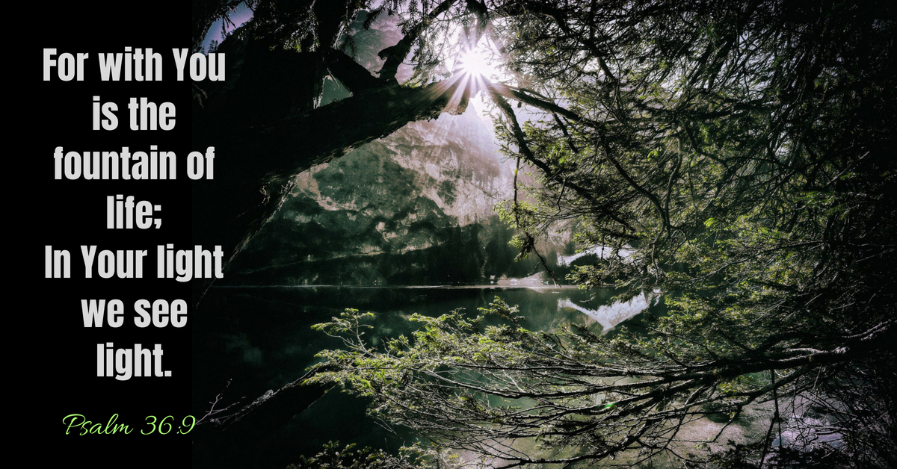

V1 I have a message from God in my heart concerning the sinfulness of the wicked.
V2 In their own eyes they flatter themselves too much to detect or hate their sin.
V7 How priceless is your unfailing love, O God! People take refuge in the shadow of your wings.
V8 They feast in the abundance of your house; you give them drink from your river of delights.
V9 For with you is the fountain of life; in your light we see light.

The world we live in seems very fragile, full of deserts, rocky and arctic wastes and with the environment threatened about us. We probably felt pretty safe and secure until the coronavirus gave us a sudden shock.

Is there enough to go round, as we observe the empty supermarket shelves? People hold tightly to their possessions. If someone is blessed (me?) am I taking away from someone else’s blessing?

But God is a God of abundance. He is infinite, generous and full of grace. We are told there is more than enough to go around. So we can hold things lightly and we can give things freely.

Can we help our world? Look after it better? Care about people we see each day? Make an effort to contribute? Then we shall see again.

Michael of St Stephens
(with a little help from this year’s
Lent booklet from TEARFUND!)

