**RECEPIE PAGE**



**Damson Jam**

4lbs damsons

5lbs sugar

1 pt water

Remove stems and put cleaned fruit in a pan with water. Bring slowly to the boil and simmer for about 20mins. Stir in sugar and bring slowly back to boil, then boiled rapidly until it sets when tested, about 15-20 mins. Pour into jars*. (Mrs S Taziker 1987)*

**Scones**

1 egg

3oz butter or margarine

2oz sugar

6oz S R Flour

5 cherries cut up and a handful of sultanas

Juice of 1 lemon

Cream Butter and sugar, beat in egg, then gradually add all other ingredients. Shape into a round with we hands and mark with a cross. Bake in a moderate oven, Gas Mark 6, for about 20mins.

*(Miss Brooks from Common Favourites 3)*

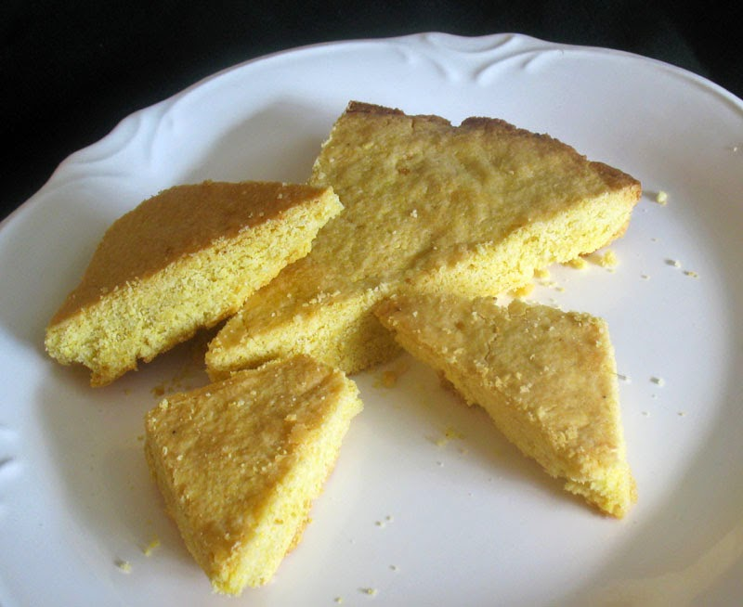

**Rich Shortbread**

9oz S R Flour

3oz sugar

6oz butter or marg

Mix flour and sugar in a bowl, then rub in the butter. Knead well to form a smooth paste, then divide into 2 equal parts and shape and flatten into 2 rounds about 1/2inch thick. Mark top into portions, decorate edges and prick with a fork.

Place on a greased baking tray and bake until pale and golden, Gas Mk 3.

*(Mrs J Yates Common Favourites 3)*

**Apple and banana cake**

2 apples and 2 bananas

6oz soft brown sugar

4oz margarine

2 large eggs

8os Self Raising Flour

2oz mixed fruit

2 level teaspoons of cinnamon

Grate apple and mash bananas, mix together with the margarine, sugar and eggs. Add flour, mixed fruit and cinnamon, mix with a wooden spoon.

Place mixture in a lined and greased swiss roll tin and bake for 30-35 minutes at gas 5 or 375°.

*(Mrs Sybil Hall from Common Favourites Volume 2)*



**Fish cakes**



One small tin of salmon, 6 well mashed potatoes and 1 well beaten egg. Mix together, form into small cakes and fry a golden brown.

*(Mrs Elliot. Mosley Common Magazine July 1938)*

