Church for a Different World
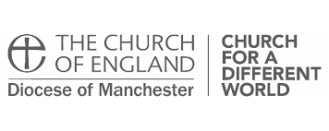
Using technology to keep in touch
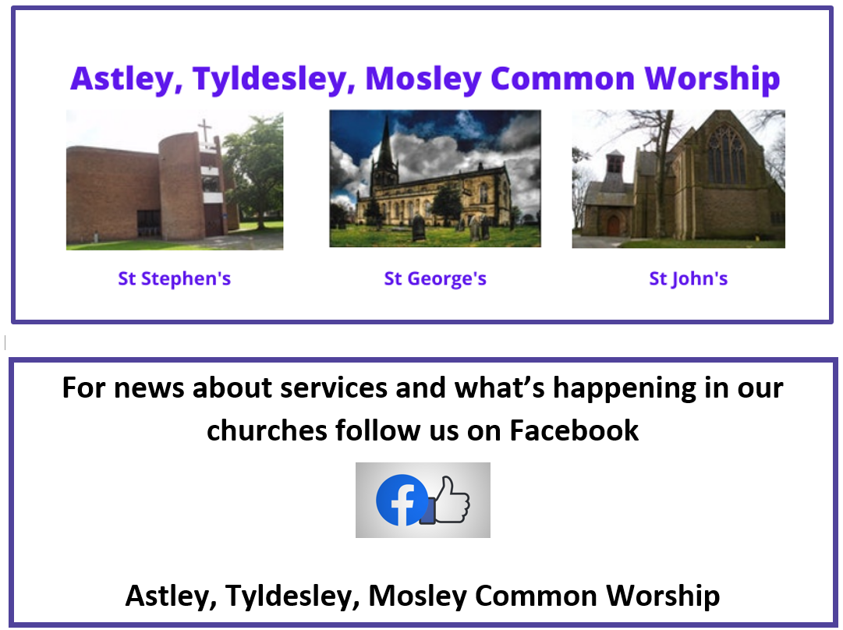
During Lockdown we’ve had to
adjust to being ‘church for a
different world’ and embrace the
technological age. This is very
much work in progress but the new
Astley, Tyldesley, Mosley
Common Team Worship page on
Facebook will, amongst other
things, provide a platform for
services to be broadcast from.

And, for those who prefer not to use
Facebook, services can also be
found on the newly created Team
You Tube Channel – search for
ATMCTeam Media

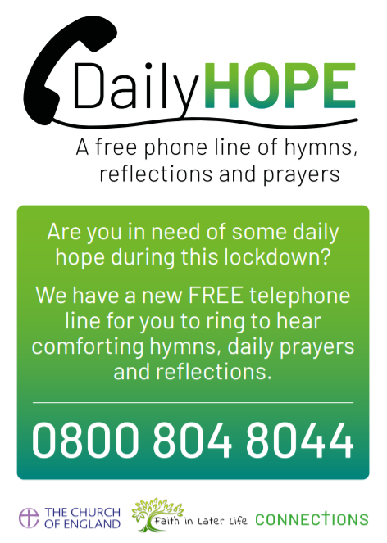
We are also aware that a number of
people will not have access to the
Internet so, the Church of England
has also provided a telephone line
where prayers, reflections and
hymns can be heard daily.

