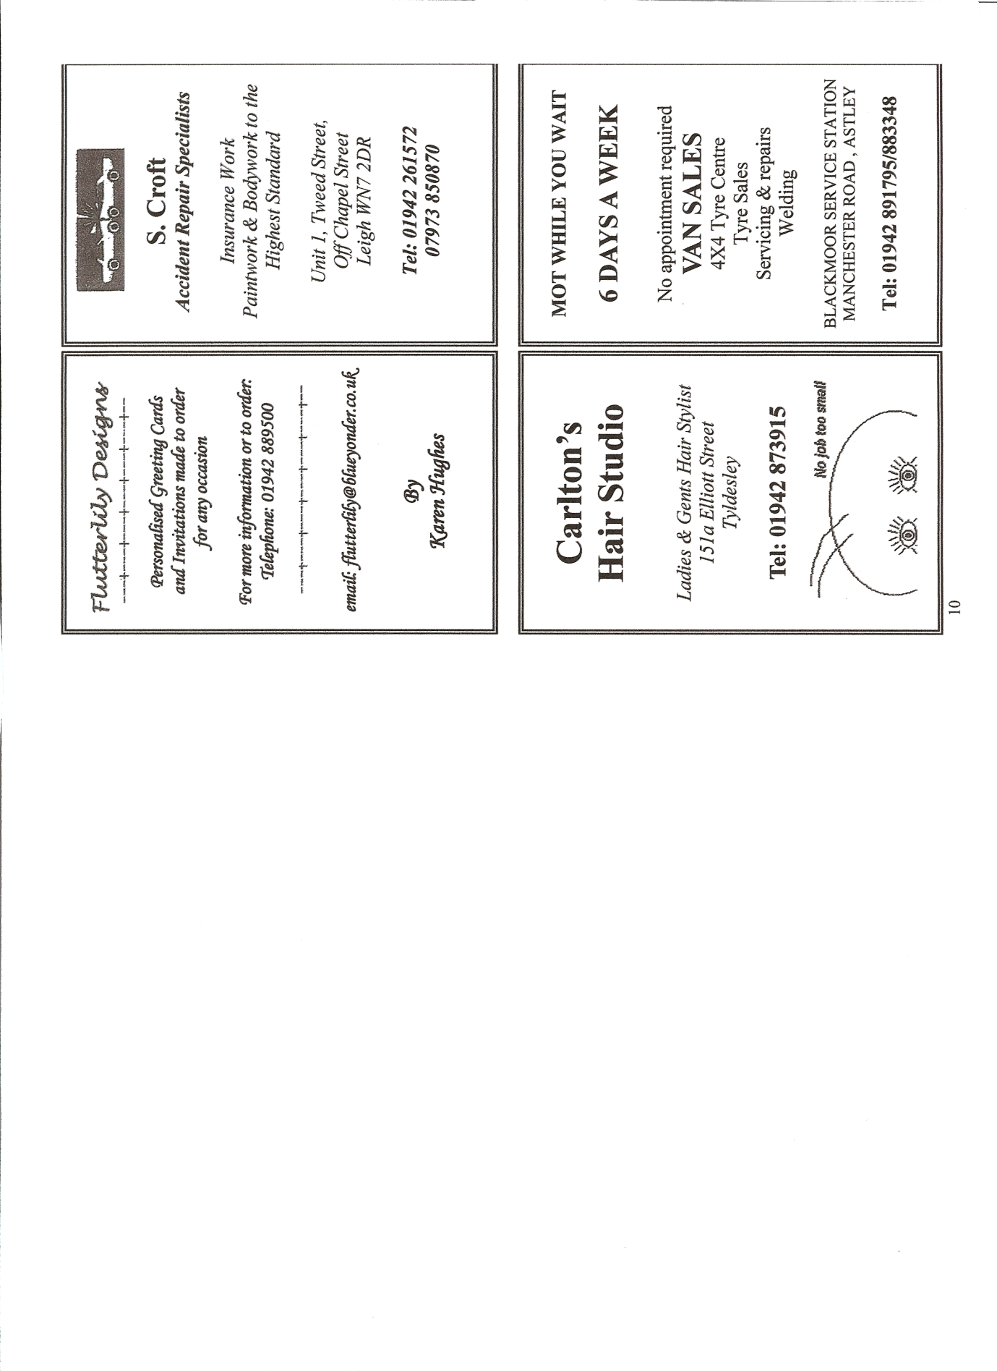

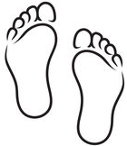

BEST FOOT FORWARD

Laura Hayes
HCPC Registered
Podiatrist/Chiropodist

182 Elliott St., Tyldesley
M29 8DS

01942 665085

