Places in the Bible
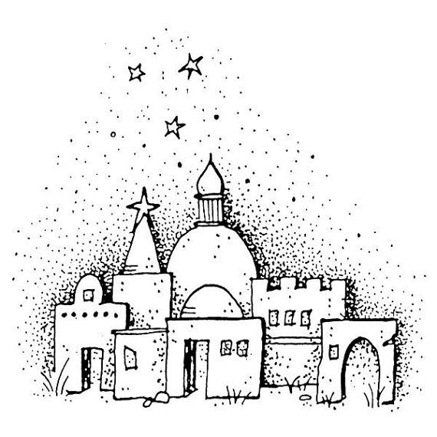
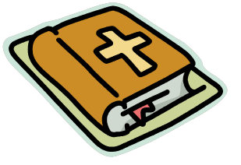

b | a | b | y | l | o | n | b | g | b
j | r | p | e | r | s | i | a | h | e
e | f | s | o | d | o | m | h | e | t
r | s | h | e | b | a | h | u | b | h
i | g | a | l | i | l | e | e | r | l
c | t | j | u | d | a | h | b | o | e
h | m | u | q | k | s | r | a | n | h
o | b | j | w | u | c | t | b | u | e
j | e | r | u | s | a | l | e | m | m
a | e | o | i | h | p | u | l | i | j
f | d | a | m | a | s | c | u | s | f
f | e | s | i | d | o | n | n | o | d
a | n | a | z | a | r | e | t | h | k

Jerusalem Babel Bethlehem Damascus
Galilee Eden Hebron Jaffa
Jericho Judah Kush Nod
Nazareth Sheba Sidon Sodom
Babylon Persia
